H1 — Nose Sweeps and Odor
Are nose sweeps prevalent AND temporally/quantitatively associated with ethanol?
Verdict: H1 is NOT supported (null result).

1. Goal and Hypotheses
Goal: test whether discrete nose sweeps are (a) prevalent, (b) temporally locked to elevated local ethanol, and (c) larger when local odor is stronger — the signature expected if sweeps are an odor-guided search behavior.
H1 (alternative): nose sweeps are prevalent AND temporally associated with ethanol; peri-sweep baseline-subtracted ethanol exceeds a matched-count random-time null, and sweep magnitude R correlates positively with local odor.
H0 (null): peri-sweep ethanol is at or below the time-shuffled null, and sweep magnitude R is independent of local ethanol (Spearman rho not positive / CI includes 0).
Pre-registered acceptance rule (PLAN.md sec.4): accept H1 iff peri-sweep ethanol > null AND rho > 0 with the 95% CI excluding 0. Both conditions must hold.

2. Methods
Pipeline and accessor.
Trajectories were loaded via the project data accessor and processed with the shared reactions_common library (reactions_common/1.0). All randomness used a fixed seed (1234); 2000 permutations for null construction and 2000 bootstraps for confidence intervals.
Interpreter: the project virtual environment (vras\Scripts\python.exe), matplotlib in headless (Agg) mode.
Kinematics.
The nose was taken as the head keypoint and the COM as the body keypoint, both resampled onto the head clock (monotonic interpolation, never reversed). Per-axis velocities were computed with a Savitzky-Golay filter (window 7 frames ~70 ms, polynomial order 2, first derivative, delta = frame dt). De-jump cleaning removed 0.50% of head and 0.50% of body samples. Median speeds: v_nose 22.8 px/s (90th pct 74.9), v_com 14.2 px/s (90th pct 72.3).
Sweep magnitude R and floor.
Sweep magnitude was defined as R = v_nose / max(v_com, v_floor), where v_floor = 2.887 px/s (the 10th percentile of pooled v_com) guards against divide-by-near-zero when the animal is stationary. The floor was binding on 9.7% of pooled samples (mean fraction across trials).
Sweep detector.
Sweeps were detected on the R time series with scipy find_peaks: height >= 1.5, prominence >= 0.5, refractory (min inter-peak distance) 0.30 s. The prominence/height thresholds are editable; because R is high whenever the nose moves and the body does not, the detector fires frequently (see Caveats).
Baseline-subtracted ethanol and peri-sweep windows.
Local ethanol was baseline-subtracted on the RAW scale by subtracting a rolling 10th-percentile computed over a W = 20 s window (raw minus rolling floor). Peri-sweep signals were sampled on a 0.05 s grid over the peri window [-1.0, 1.0] s (used for the F1 curves); the summed-odor statistic integrates baseline-subtracted ethanol over the [-0.5, 0.5] s window around each sweep peak.
Unit of analysis and pooling.
The unit of analysis for per-trial tests is the trial. Location-pooled analyses use the pooled Loc1-6 set: n = 105 trials (of 114 processed), 21,841 pooled sweeps. The 'anotherLoc' condition is excluded from the pooled set.
Tests: (a) prevalence = sweep rate (sweeps/s) and count per trial; (b) paired Wilcoxon of per-trial peri-sweep ethanol vs a matched-count random-time null (observed > null); (c) Spearman rho(R@peak, summed peri-sweep ethanol), one point per sweep, CI bootstrapped over trials. No family-wise correction is applied across H1-H3 (per-test CIs only).

3. Results
3.1 Prevalence — lead with rate, not count.
Sweeps are numerically abundant but the RATE shows why that abundance is not evidence of discrete search. Median sweep rate = 1.706 sweeps/s (mean 1.628; range 0.185-2.120); median count = 111 sweeps/trial (mean 208; range 4-870); 21,841 sweeps pooled across 105 trials. A median of ~1.7 'sweeps' every second is far faster than deliberate, discrete search sweeps: the count is duration-driven and most detected events are routine nose motion rather than goal-directed sweeps.
3.2 Peri-sweep ethanol vs matched-count random-time null.
Peri-sweep baseline-subtracted ethanol is NOT significantly above the matched-count random-time null. Paired Wilcoxon (observed > null), per trial: statistic = 3150.0, p = 0.120 (n = 105 trials). The per-trial medians are nearly identical — observed 0.0323 vs null 0.0295 — a difference of only 0.0028 a.u. that does not reach significance. Odor is not reliably elevated at sweep times beyond what random timing produces.
Figure F1 (below) shows the peri-sweep time course. In F1A the mean baseline-subtracted ethanol is essentially flat across the peri window with no peak at t = 0 (the sweep peak); the first grid sample already sits at ~0.043 a.u. and the curve does not rise into the sweep. This flatness is the visual counterpart of the non-significant Wilcoxon test: there is no odor transient time-locked to sweeps. F1B shows the expected kinematic signature (a sharp v_com trough at t = 0), confirming the sweeps are real motor events even though they carry no odor signal.
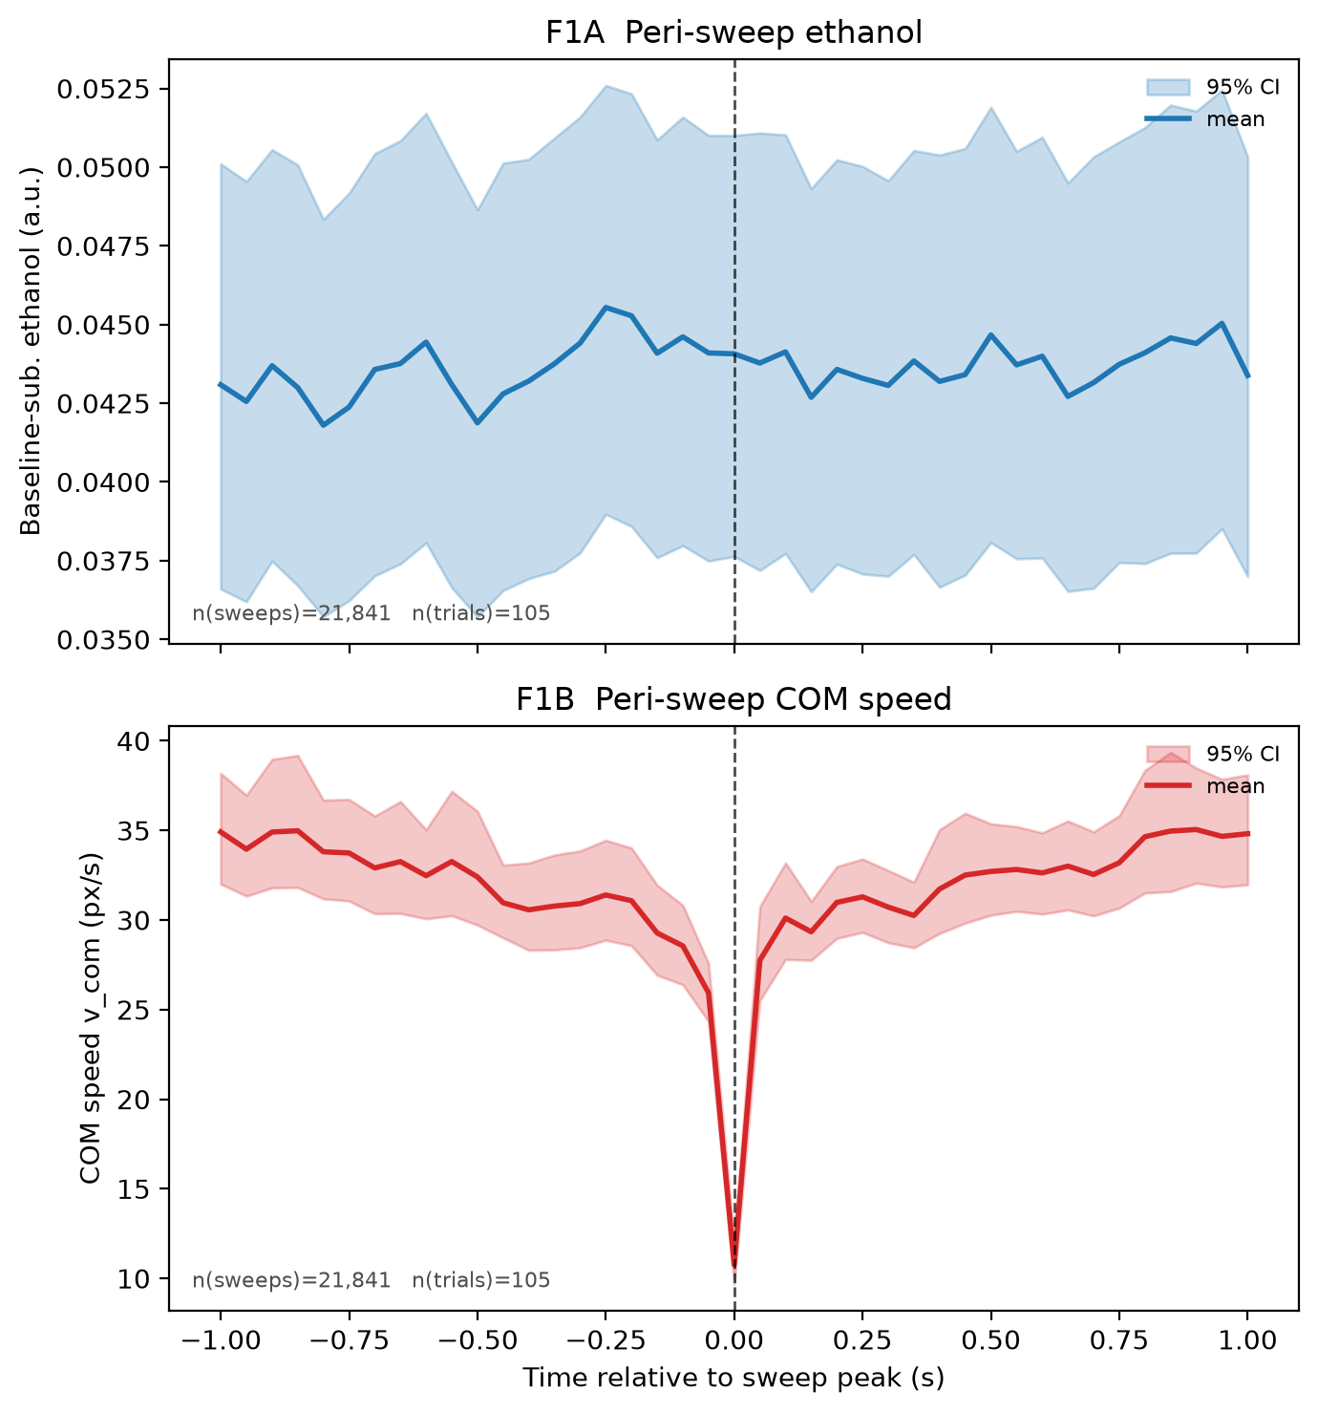
Figure F1. Peri-sweep dynamics (pooled Loc1-6; n(sweeps) = 21,841, n(trials) = 105). (F1A, top) Mean baseline-subtracted ethanol (a.u.) vs time to sweep peak over [-1.0, 1.0] s, 95% CI band; dashed line at t = 0. The curve is flat — no odor transient at the sweep. (F1B, bottom) Mean COM speed v_com (px/s), same window and CI; the trough at t = 0 confirms sweeps are genuine motor events. Source: stats.json F1A_peri_eth / F1B_peri_vcom.
3.3 Sweep magnitude vs local odor (H1c) — magnitude first.
The pre-registered H1(c) statistic is the Spearman correlation between sweep magnitude R at the peak and summed peri-sweep baseline-subtracted ethanol (one point per sweep, n = 21,794). rho = -0.0281. This is NEGLIGIBLE in magnitude (essentially zero) and NEGATIVE in direction — the opposite of the predicted positive relationship. Although the 95% CI [-0.0565, -0.0003] barely excludes zero and the p-value is small (p = 3.36e-05), that significance is an artifact of the enormous number of sweeps, not a meaningful effect. An effect size of ~0 in the wrong direction cannot support H1 regardless of its p-value.
Figure F2B (below) plots the same relationship using nose speed at the peak on the x-axis (per the figure spec) against summed peri-sweep odor. The plotted-point Spearman is rho = -0.091 (95% CI [-0.104, -0.078], p = 2.78e-41, n = 21,794) — again a near-zero, non-positive relationship. Whether the axis is sweep magnitude R (the inferential test) or nose speed (the figure), stronger nose motion is not accompanied by more local odor.
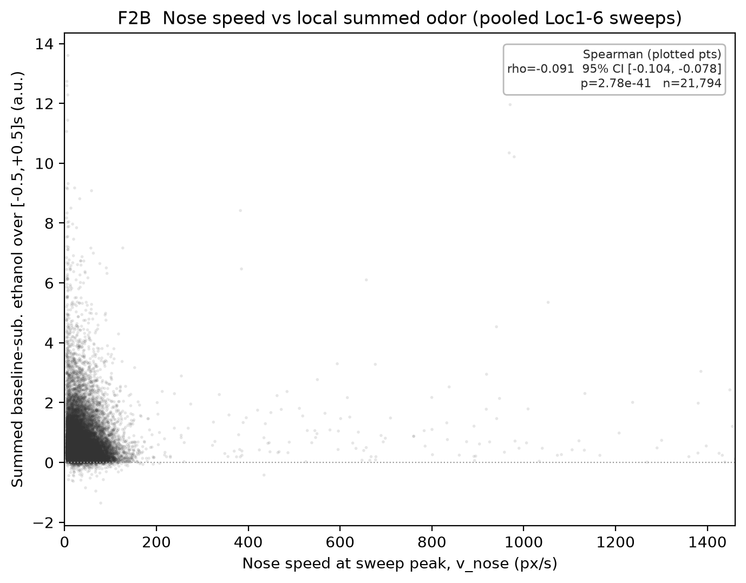
Figure F2B. Nose speed at sweep peak (px/s) vs summed baseline-subtracted ethanol over [-0.5, 0.5] s (a.u.), one point per pooled Loc1-6 sweep (n = 21,794). Annotated Spearman rho = -0.091, 95% CI [-0.104, -0.078], p = 2.78e-41 describe the plotted points (seed 1234). The pre-registered H1(c) inferential statistic is the R-based rho = -0.0281 (CI [-0.0565, -0.0003], p = 3.36e-05) reported in the text; both are near-zero, non-positive nulls. Source: sweeps.h5 /sweeps columns v_nose, summed_eth, in_pooled.
3.4 Absolute-amplitude check.
Peri-sweep baseline-subtracted ethanol (median 0.0218 a.u., 90th pct 0.0732) sits above the deconvolution noise floor (~4e-04 a.u.) — confirmed above floor — and 78.6% of sweeps have mean peri-sweep ethanol > 0.01. So sweeps do occur where SOME odor is present. However, that amplitude is a small fraction of the real dynamic range of the signal (~0.14 a.u.): the odor present at sweeps is weak, and (per 3.2-3.3) it is neither elevated relative to random timing nor scaled with sweep size. Being above the noise floor is necessary but not sufficient for an odor-guided-search claim.

3.5 Result summary
Test | Result | Predicted / criterion | Supports H1?
(a) Prevalence (rate) | median 1.706 sweeps/s; median 111/trial; 21,841 pooled | prevalent AND discrete | Abundant but rate too high -> routine motion, not discrete search
(b) Peri-sweep eth vs null | Wilcoxon p = 0.120; obs 0.0323 vs null 0.0295 | observed > null (p < 0.05) | No (not significant)
(c) rho(R, summed odor) | rho = -0.0281; CI [-0.0565, -0.0003]; p = 3.4e-05 | rho > 0, CI excludes 0 | No (~0 and negative)
Amplitude check | median 0.0218 a.u.; 78.6% sweeps > 0.01; above floor | above noise floor | Above floor but weak vs ~0.14 range
Bottom line: acceptance requires peri-sweep ethanol > null AND rho > 0 with CI excluding 0. Neither holds — the peri-vs-null test is non-significant and rho is ~0 and negative. H1 is NOT supported.

4. Caveats and limitations
- Sweeps are mostly routine motion. The R-based sweep detector (height >= 1.5, prominence >= 0.5, refractory 0.30 s) fires at a median ~1.7/s. At that rate the great majority of detected 'sweeps' are routine nose motion, not discrete, deliberate search sweeps. Thresholds are editable; a stricter detector would yield fewer, more sweep-like events but was not the pre-registered analysis.
- Tiny-but-significant N artifact. The H1(c) correlation is statistically significant (p = 3.4e-05) only because n = 21,794 sweeps makes even a rho of -0.028 'significant'. The effect size is ~0 and in the wrong direction; significance here reflects sample size, not biology. We lead with magnitude and direction, not the p-value.
- Uncalibrated units, single cohort. Ethanol is in uncalibrated arbitrary units and positions in pixels; the amplitude check is relative to an internal range/noise-floor reference, not an absolute concentration. Results are from a single cohort/experimental setup, so generalization is unestablished.

5. Reproducibility
Random seed 1234; library reactions_common/1.0; results generated 2026-08-08T19:35:19Z.
Exact commands (interpreter = vras\Scripts\python.exe):
"$AR_PY" code\build_h1_figures.py # builds F1 and F2B (png+pdf+txt)
"$AR_PY" code\build_h1_report.py # builds this DOCX
Result files consumed: data\stats.json (keys H1a_prevalence, H1b_peri_sweep_odor, H1c_spearman, H1_amplitude_check, F1A_peri_eth, F1B_peri_vcom, meta); data\sweeps.h5 (/sweeps columns v_nose, summed_eth, in_pooled). Figures: reports\figures\F1_peri_sweep_odor_and_com.{png,pdf,txt}, reports\figures\F2B_nose_vs_summed_odor.{png,pdf,txt}. All reported numbers are injected from these objects; the science was not recomputed (the only in-report computation is the Spearman of F2B's plotted points, which describes the figure).

